CS4121 Assignment 4 Due: 10/03/17

(25 points) In class, when discussion the GBN protocol for reliable data transfer, we compared two ways of estimating Round Trip Time (RTT) – exponential averaging and arithmetic averaging. We concluded that the former is better than the latter. See slides 3-73 through 3-77. (However, for the simplicity of this assignment, don’t worry about slide 3-75, which is about the deviation of sample RTTs and the safety margin.) In this question, you are asked to write a piece of Java program to prove it.

  - On a command line window, run the following ping command and direct the outputs to a text file by the name of data.txt.
You may change the name of the web server and the number of messages you want to send to it when testing your program. (I know I will when grading your program.)

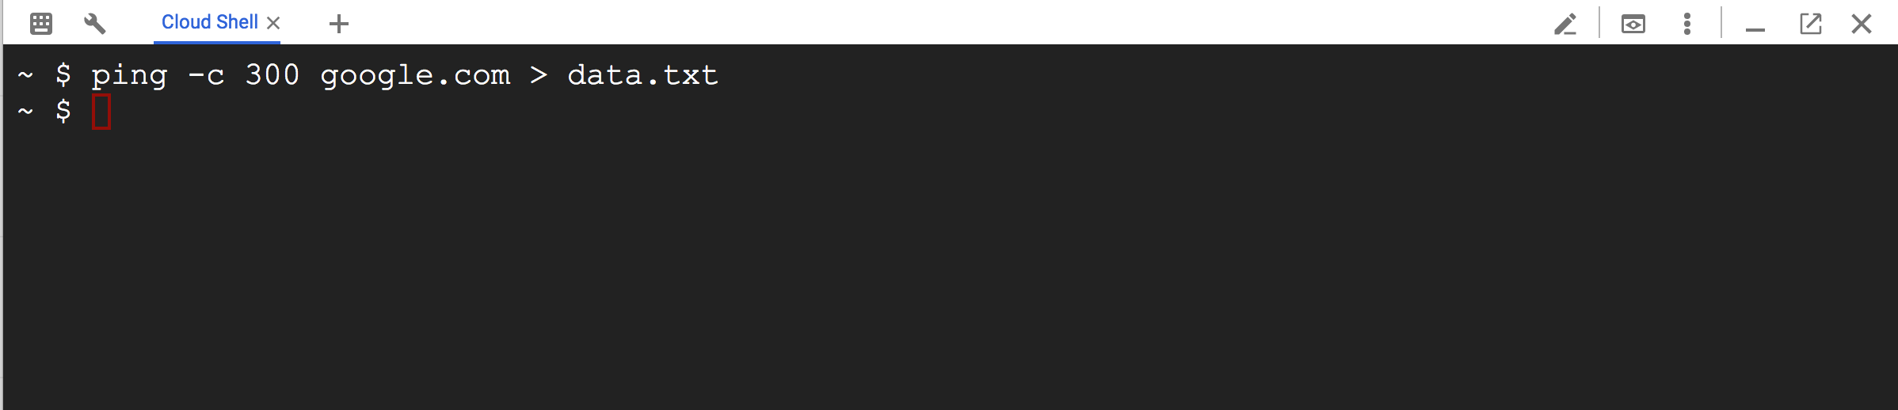

In the attachment to this assignment, please also find a sample data.txt. Make sure your program can at least handle it without crashes or errors.

  - Complete the skeleton Java program Exp_Ari_Avg.java to accomplish the following:
In the method of sampleRTT2EstimatedRTT,
    - Read each line from data.txt that begins with “Reply from” and extract the RTT time (… time=xxxms …). This is the current SampleRTT if you want to map it the notation used in the formulas on slides 3-74 and 3-76.
    - Call the method of expAvg that you have to complete to compute the next Estimated RTT (let’s call it EstRTT1) using the exponential averaging approach.
Notice that the initial estimated RTT (the first argument you pass to expAvg when you call it for the first time) can be randomly generated between 0 and 100.
    - Call the method of ariAvg that you have to complete to compute the next Estimated RTT (let’s call it EstRTT2) using the arithmetic averaging approach.
Notice that the initial estimated RTT (the first argument you pass to ariAvg when you call it for the first time) can be randomly generated between 0 and 100.
    - Write SampleRTT, EstRTT1, and EstRTT2 to the output file by the name of output.txt. (Use tabs to separate them and change to a new line after the writes.)

Important: no matter how you implement your program, you are not allowed to use any collection type of data structure like array, ArrayList, etc.

  - Plot the results. I outline how to do it in MS excel below. You may choose any tool that you feel comfortable with.
Launch MS excel, open output.txt. (You need to change the “Files of type:” to “All Files”. Hit Next twice and Finish once.) Select all data by pressing Ctrl-A. Then Click Insert, select Line (in the group of Charts), and pick Line with Markers (first one on the second row). Select Layout 3 (from the group of Chart Layouts” and change the Chart Title to “RTT Estimation Exponential Averaging v.s. Arithmetic Averaging”. Save the file as output.xlsx. See a sample below.

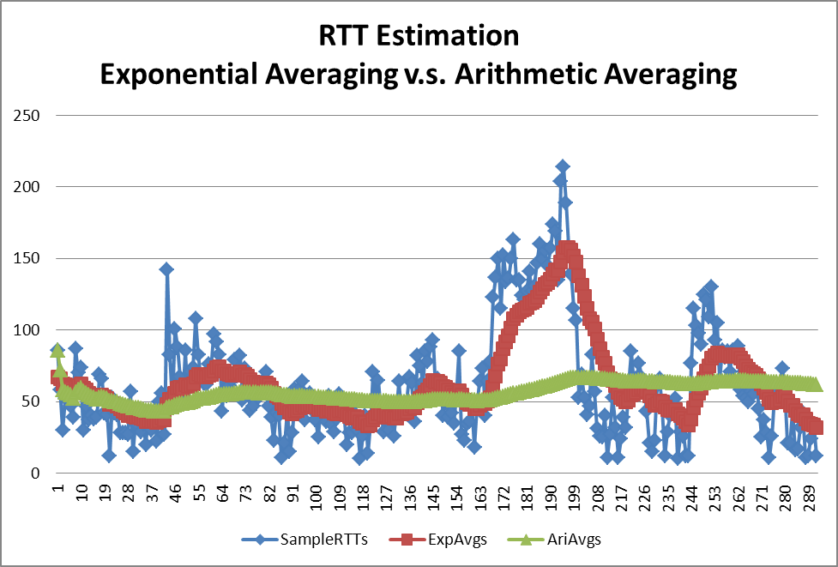

What to turn in?

For this assignment I need you submit a zip file by the name of cs4121_a3_yourlastname.zip that includes the following two files:
- Completed program Exp_Ari_Avg.java for the question above.
- output.xlsx (that contains output data from your Java program and a comparison chart) for the question above.

